Project Planning Phase
Project Planning Template (Product Backlog, Sprint Planning, Stories, Story points)

Date | 28 September 2026
Team ID | SWTID-2026-2169
Project Name | Import Data using Transform Maps (Spreadsheet)
Maximum Marks | 5 Marks

Product Backlog, Sprint Schedule, and Estimation (4 Marks)
Use the below template to create product backlog and sprint schedule

Sprint | Functional Requirement (Epic) | User Story Number | User Story / Task | Story Points | Priority | Team Members
Sprint-1 | Creation of spreadsheet | USN-1 | As a user, I can register for the application by entering my email, password, and confirming my password. | 2 | High | P.Muthu Rani
Sprint-1 | Creation of table | USN-2 | As a user, I will receive confirmation email  once I have registered for the application | 1 | High | S.Uthaya  Lakshmi
Sprint-1 | Create import set table | USN-3 | As a user, I can register for the application through Facebook | 3 | High | A.Mariya Cinterlla
Sprint-1 | Create Transform Map | USN-4 | As a user, I can register for the application through Gmail | 2 | Medium | A.Mariya Cinterlla
Sprint-2 | Transform data and  validate | USN-5 | As a user, I can log into the application by  entering email & password | 2 | High | P.Muthu  Rani
Sprint-2 | Enable Coalesce to  avoid duplicate records | USN-6 | As a user, I can run the Transform Map and import the transformed data. | 3 | Medium | S.Uthaya Lakshmi

Sprint | Functional Requirement (Epic) | User Story Number | User Story / Task | Story Points | Priority | Team Members
Sprint-2 | Inserting new data  in Excel format | USN-7 | As a user, I can identify and handle missing  values or errors. | 2 | Medium | S.Uthaya  Lakshmi
Sprint-2 | Data Validation | USN-8 | As a user, I can verify the final records in the target table. | 3 | High | A.Mariya Cinterlla

Project Tracker, Velocity & Burndown Chart: (4 Marks)

Sprint | Total Story Points | Duration | Sprint Start Date | Sprint End Date (Planned) | Story Points Completed (as on  Planned End Date) | Sprint Release Date (Actual)
Sprint-2 | 8 | 6 Days | 28 Sep 2026 | 03 Oct 2026 | 8 | 03 Oct 2026
Sprint-2 | 10 | 6 Days | 05 Oct 2026 | 10 Oct 2026 | 10 | 10 Oct 2026
Total | 8 | 6 Days | 12 Oct 2026 | 17 Oct 2026 | 8 | 17 Oct 2026
Sprint-4 | 9 | 6 Days | 19 Oct 2026 | 24 Oct 2026 | 9 | 24 Oct 2026
Total | 35 | 24 Days |  |  | 35
Velocity:
Imagine we have a 10-day sprint duration, and the velocity of the team is 20 (points per sprint). Let’s calculate the team’s average velocity (AV) per iteration unit (story points per day)

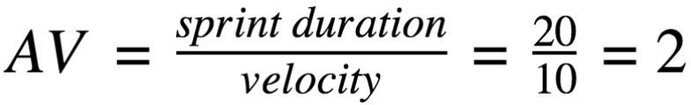
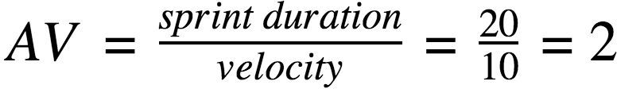

Burndown Chart:
A burn down chart is a graphical representation of work left to do versus time. It is often used in agile software development methodologies such as Scrum. However, burn down charts can be applied to any project containing measurable progress over time.

https://www.visual-paradigm.com/scrum/scrum-burndown-chart/ https://www.atlassian.com/agile/tutorials/burndown-charts

